14.66: The ball’s volume is
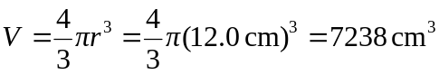
As it floats, it displaces a weight of water equal to its weight. a) By pushing the ball under water, you displace an additional amount of water equal to 84% of the ball’s volume or 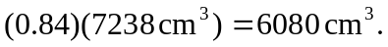 This much water has a mass of and weighs 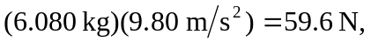which is how hard you’ll have to push to submerge the ball.
b) The upward force on the ball in excess of its own weight was found in part (a): 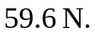 The ball’s mass is equal to the mass of water displaced when the ball is floating:

and its acceleration upon release is thus

